THE HERO’S JOURNEY
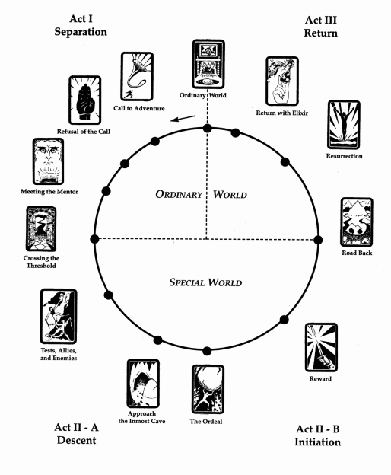

The Ordinary World
The Hero is introduced. He is shown in his Ordinary World, which is nothing special and a complete contrast to the Special World he will later venture into. He has a sad, boring life that usually gets the reader to sympathize and/or identify with him.

The Call to Adventure
Within his Ordinary World, the Hero receives some form of information that shakes up the situation and acts as the call to adventure. The Hero is being prompted to leave the Ordinary World for the Special World. This is where he is beginning a new stage in his life. (Inciting event)

Refusal of the Call
The Hero experience some refusal to answer the call and turn away from the adventure, perhaps by feelings of insecurity, obligation, or fear of the unknown.

Meeting with the Mentor
The Hero meets a guide or protector or some form of magical helper—often a seasoned traveler—who offer the Hero training, knowledge, confidence, advice, and such that will help the Hero on his journey. The key word is that the Mentor offers help and guidance while the Hero is the one who should complete the journey.

Crossing the Threshold to the Special World
At the end of this first part, the Departure, the Hero commits to leaving the Ordinary World and crossing into the adventure and the Special World. This new unknown and dangerous world contains rules the Hero is not familiar with. While the Mentor lead the Hero to the threshold, the Hero has to cross it on his own. The threshold is also guarded by a Guardian or Gatekeeper, which means the Hero must prove to be worthy in order to pass the threshold. (Act 1 choice)

Tests, Allies and Enemies
The Hero explores this new and unknown world and goes through tests and trials within this unfamiliar setting. He learns new things and skills that will prepare him for the Ordeal that’s to come. The Hero should not succeed at every test, he should know what failure feels like (because this will make him grow). He will also encounter new characters and sort out friends from foes. His new companions will help him with the tests and trials. (1st half of Act 2)

Approach to the Innermost Cave
The Hero prepares for the major challenge in the Special World—together with his friends—by facing greater challenges and more difficult obstacles and guardians. This is a way to prove himself worthy of greater challenges and the ultimate battle.

The Ordeal
The Hero faces his greatest challenge yet, in the form of the Antagonist, with the knowledge and skills he has obtained up until now. He confronts death or his deepest fear. He then experiences death and rebirth (either literal or symbolic). (Midpoint)

The Reward
The Hero takes possession of the reward/treasure he won by facing his greatest challenge, marking his triumph over the Antagonist. This reward/treasure is what the Hero went on the journey to get (it does not have to be something material, though). (2nd half f Act 2)

The Road Back
The Hero is driven to complete the adventure by going back to the Ordinary World with the reward/treasure he won. It can often be as dangerous to return from the journey as it was to start it in the first place. There is often a chase scene that signals the urgency and danger of the mission, or the defeated Antagonist may be rallying for a second round.

The Resurrection
The Hero is once again tested on the threshold going back to the Ordinary World (this may be brought about by a rebounding Antagonist who must be conquered once more). The Hero experiences a final moment of death and resurrection that’s on a higher and more complete level than the previous one, so that he is pure when he reenters the Ordinary World. This resurrection may either be literal or symbolical, and he wakes to a new world and transformed life. (Climax)

Return with the Elixir
The Hero returns home with some element of the reward/treasure that will help him improve the Ordinary World (it can just as well be a material thing as a greater insight into himself as a person). Usually, the elixir (the reward/treasure) is meant to help someone other than the Hero—what the Hero gained on his journey will benefit others beyond himself.

